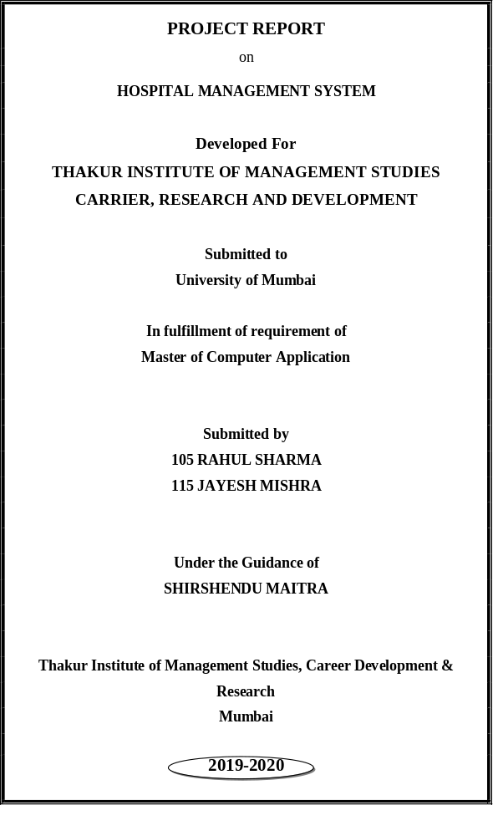

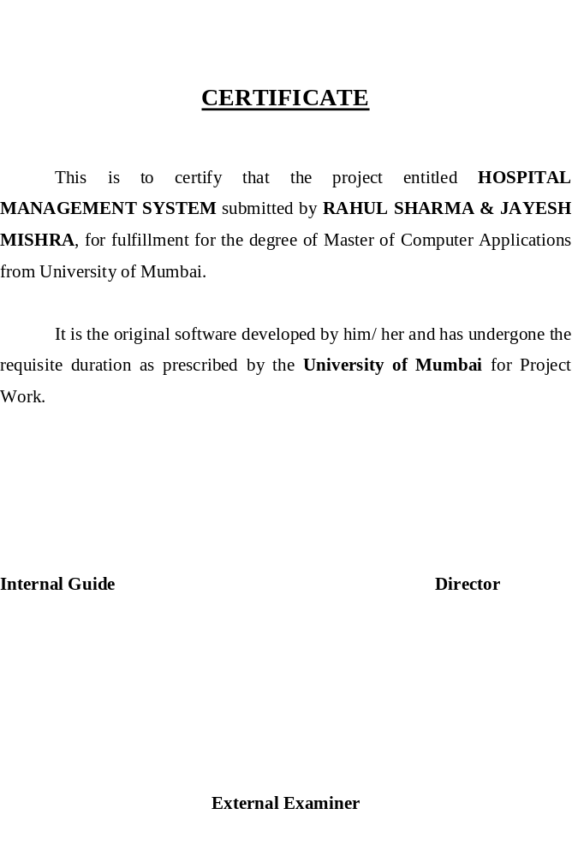

PREFACE

It gives me a pleasure to present the project on “Hospital Management System”
prepared sincerely, punctually and with utmost efforts.

The contents of this book are presented into many Chapters, in order to ease reading. The project has been illustrated with precious data elucidated with neat Dataflow
Diagram. Entity-Relationship Diagram and Structural Diagram that simplify the understanding of the project. The project includes the software development tools like (Visual Studio code and MySQL server 2008)

Meticulous care has been taken to make this project perfect and useful in every respect.

RAHUL SHARMA

INDEX

S. N CONTENTS

- INTRODUCTION
2. ANALYSIS
2.1 SYSTEM ANALYSIS
2.2 SYSTEM SPECIFICATIONS
3. DESIGN APPROACH
3.1 INTRODUCTION TO DESIGN
3.2 UML DIAGRAMS
3.3 DATA FLOW DIAGRAMS
3.4 E-R DIAGRAMS
4. PROJECT MODULES
5. IMPLEMENTATION
4.1 CONCEPTS AND TECHNIQUES
4.2 TESTING
4.2.1 TEST CASES
6. OUTPUT SCREENS
7. CONCLUSION
8. FUTURE ENHANCEMENTS
9. BIBILIOGRAPHY

Hospital Management System

ABSTRACT

OBJECTIVE :

Hospitals currently use a manual system for the management and maintenance of critical information. The current system requires numerous paper forms, with data stores spread throughout the hospital management infrastructure. Often information (on forms) is incomplete, or does not follow management standards. Forms are often lost in transit between departments requiring a comprehensive auditing process to ensure that no vital information is lost. Multiple copies of the same information exist in the hospital and may lead to inconsistencies in data in various data stores.
A significant part of the operation of any hospital involves the acquisition, management and timely retrieval of great volumes of information. This information typically involves; patient personal information and medical history, staff information, room and ward scheduling, staff scheduling, operating theater scheduling and various facilities waiting lists. All of this information must be managed in an efficient and cost wise fashion so that an institution's resources may be effectively utilized HMS will automate the management of the hospital making it more efficient and error free. It aims at standardizing data, consolidating data ensuring data integrity and reducing inconsistencies.

PROJECT OVERVIEW :

The Hospital Management System (HMS) is designed for Any Hospital to replace their existing manual, paper based system. The new system is to control the following information; patient information, room availability, staff and operating room schedules, and patient invoices. These services are to be provided in an efficient, cost effective manner, with the goal of reducing the time and resources currently required for such tasks.
A significant part of the operation of any hospital involves the acquisition, management and timely retrieval of great volumes of information. This information typically involves; patient personal information and medical history, staff information, room and ward scheduling, staff scheduling, operating theater scheduling and various facilities waiting lists. All of this information must be managed in an efficient and cost wise fashion so that an institution's resources may be effectively utilized HMS will automate the management of the hospital making it more efficient and error free. It aims at standardizing data, consolidating data ensuring data integrity and reducing inconsistencies.

SYSTEM DESIGN:
In this software we have developed some forms. The brief description about them is as follow:-

Reception:

The reception module handles various enquiries about the patient's admission and discharge details, bed census, and the patient's movements within the hospital. The system can also handle fixed-cost package deals for patients as well as Doctor Consultation and Scheduling, Doctor Consultancy Fees and Time Allocation.
- Doctor login
- Patient registration

Administration:
This module handles all the master entry details for the hospital requirement such as consultation detail, doctor specialization, consultancy fee, and service charges.
Employee
- Employee Detail Recording.
- Doctor Type .
- Doctor Master
- Referral Doctor

Pharmacy:
This module deals with all medical items. This module helps in maintaining Item Master, Receipt of Drugs/consumables, issue, handling of material return, generating retail bills, stock maintenance. It also helps in fulfilling the requirements of both IPD and OPD Pharmacy.

Laboratory:
This module enables the maintenance of investigation requests by the patient and generation of test results for the various available services, such as clinical pathology, X-ray and ultrasound tests. Requests can be made from various points, including wards, billing, sample collection and the laboratory receiving point. The laboratory module is integrated with the in-patient/ outpatient registration, wards and billing modules.

Registration:
This module helps in registering information about patients and handling both IPD and OPD patient’s query. A unique ID is generated for each patient after registration. This helps in implementing customer relationship management and also maintains medical history of the patient.

SOFTWARE REQUIREMENTS :

Web Technologies : HTML,CSS,JAVASCRIPT

Language : PHP

Database : MySql

Web Server : Apachi

Operating System : WINDOWS XP/7/10

INTRODUCTION:

Documenting the assembly, maintenance, use, and troubleshooting of a system as complex as a voting system is a difficult task. A single system might combine proprietary hardware, custom operating systems and software, commodity personal computers, and pen and paper. Describing these highly varied components is one function of voting system documentation .But it is not only voting system technology that is heterogeneous; so are voting systems users, and the environments in which the systems are used. Election officials, poll workers, and voters often need guidance from documents in order to administer or use a voting system. In addition, voting system certification—the process by which a system is approved for use in state— demands evidence that a voting system complies with one or more sets of standards or guidelines.

Documentation provides the details that certification bodies need to evaluate the
System. Taken as a whole, voting system documentation must explain the system in several ways to meet the needs of these multiple audiences.

As the modern organizations are automated and computers are working as per the instructions, it becomes essential for the coordination of human beings, commodity and computers in a modern organization.

Many big cities where the life is busy needs the transaction of the goods within few minutes of time. So, this online information recorded by the distributor helps him to complete this task within the time.

The administrators and all the others can communicate with the system through this project, thus facilitating effective implementation and monitoring of various activities of the voting Software.

ANALYSIS

1. EXISTING SYSTEM

Hospitals currently use a manual system for the management and maintenance of critical information. The current system requires numerous paper forms, with data stores spread throughout the hospital management infrastructure. Often information (on forms) is incomplete, or does not follow management standards. Forms are often lost in transit between departments requiring a comprehensive auditing process to ensure that no vital information is lost. Multiple copies of the same information exist in the hospital and may lead to inconsistencies in data in various data stores.

2. PROPOSED SYSTEM

The Hospital Management System (HMS) is designed for Any Hospital to replace their existing manual, paper based system. The new system is to control the following information; patient information, room availability, staff and operating room schedules, and patient invoices. These services are to be provided in an efficient, cost effective manner, with the goal of reducing the time and resources currently required for such tasks.

3. OBJECTIVE OF THE SYSTEM

Hospitals currently use a manual system for the management and maintenance of critical information. The current system requires numerous paper forms, with data stores spread throughout the hospital management infrastructure. Often information (on forms) is incomplete, or does not follow management standards. Forms are often lost in transit between departments requiring a comprehensive auditing process to ensure that no vital information is lost. Multiple copies of the same information exist in the hospital and may lead to inconsistencies in data in various data stores.
A significant part of the operation of any hospital involves the acquisition, management and timely retrieval of great volumes of information. This information typically involves; patient personal information and medical history, staff information, room and ward scheduling, staff scheduling, operating theater scheduling and various facilities waiting lists. All of this information must be managed in an efficient and cost wise fashion so that an institution's resources may be effectively utilized HMS will automate the management of the hospital making it more efficient and error free. It aims at standardizing data, consolidating data ensuring data integrity and reducing inconsistencies.
.

System Specifications

HARDWARE REQUIREMENTS:-

- Pentium-IV(Processor).
- 256 MB Ram
- 512 KB Cache Memory
- Hard disk 10 GB
- Microsoft Compatible 101 or more Key Board

SOFTWARE REQUIREMENTS: -

- Operating System : Windows XP/7/10
- Programming language: Html
- Web-Technology: PHP 2.0
- Front-End: C#Html
- Back-End: MySQL Server 2000
- Web Server: IIS

DESIGN

INTRODUCTION:
Design is the first step in the development phase for any techniques and principles for the purpose of defining a device, a process or system in sufficient detail to permit its physical realization.

Once the software requirements have been analyzed and specified the software design involves three technical activities - design, coding, implementation and testing that are required to build and verify the software.

The design activities are of main importance in this phase, because in this activity, decisions ultimately affecting the success of the software implementation and its ease of maintenance are made. These decisions have the final bearing upon reliability and maintainability of the system. Design is the only way to accurately translate the customer’s requirements into finished software or a system.

Design is the place where quality is fostered in development. Software design is a process through which requirements are translated into a representation of software. Software design is conducted in two steps. Preliminary design is concerned with the transformation of requirements into data.

UML Diagrams:

Actor:
A coherent set of roles that users of use cases play when interacting with the use `cases.

Use case:
A description of sequence of actions, including variants, that a system performs that yields an observable result of value of an actor.

UML stands for Unified Modeling Language. UML is a language for specifying, visualizing and documenting the system. This is the step while developing any product after analysis. The goal from this is to produce a model of the entities involved in the project which later need to be built. The representation of the entities that are to be used in the product being developed need to be designed.
There are various kinds of methods in software design:
They are as follows:
- Use case Diagram
- Sequence Diagram
- Collaboration Diagram
- Activity Diagram
- State chat Diagram

USECASE DIAGRAMS:

Use case diagrams model behavior within a system and helps the developers understand of what the user require. The stick man represents what’s called an actor.
Use case diagram can be useful for getting an overall view of the system and clarifying who can do and more importantly what they can’t do.
Use case diagram consists of use cases and actors and shows the interaction between the use case and actors.

- The purpose is to show the interactions between the use case and actor.
- To represent the system requirements from user’s perspective.
- An actor could be the end-user of the system or an external system.

USECASE DIAGRAM:

A Use case is a description of set of sequence of actions Graphically it is rendered as an ellipse with solid line including only its name. Use case diagram is a behavioral diagram that shows a set of use cases and actors and their relationship. It is an association between the use cases and actors. An actor represents a real-world object.

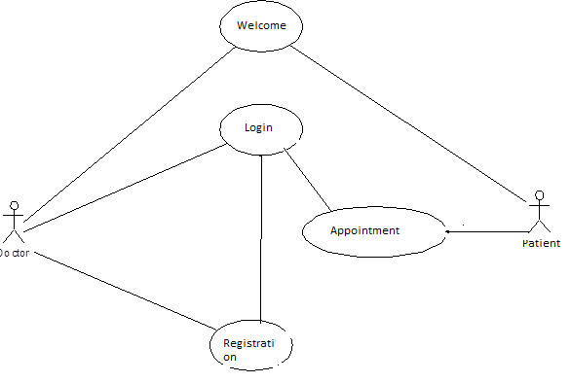

SEQUENCE DIAGRAM:

Sequence diagram and collaboration diagram are called INTERACTION DIAGRAMS. An interaction diagram shows an interaction, consisting of set of objects and their relationship including the messages that may be dispatched among them.
A sequence diagram is an introduction that empathizes the time ordering of messages. Graphically a sequence diagram is a table that shows objects arranged along the X-axis and messages ordered in increasing time along the Y-axis

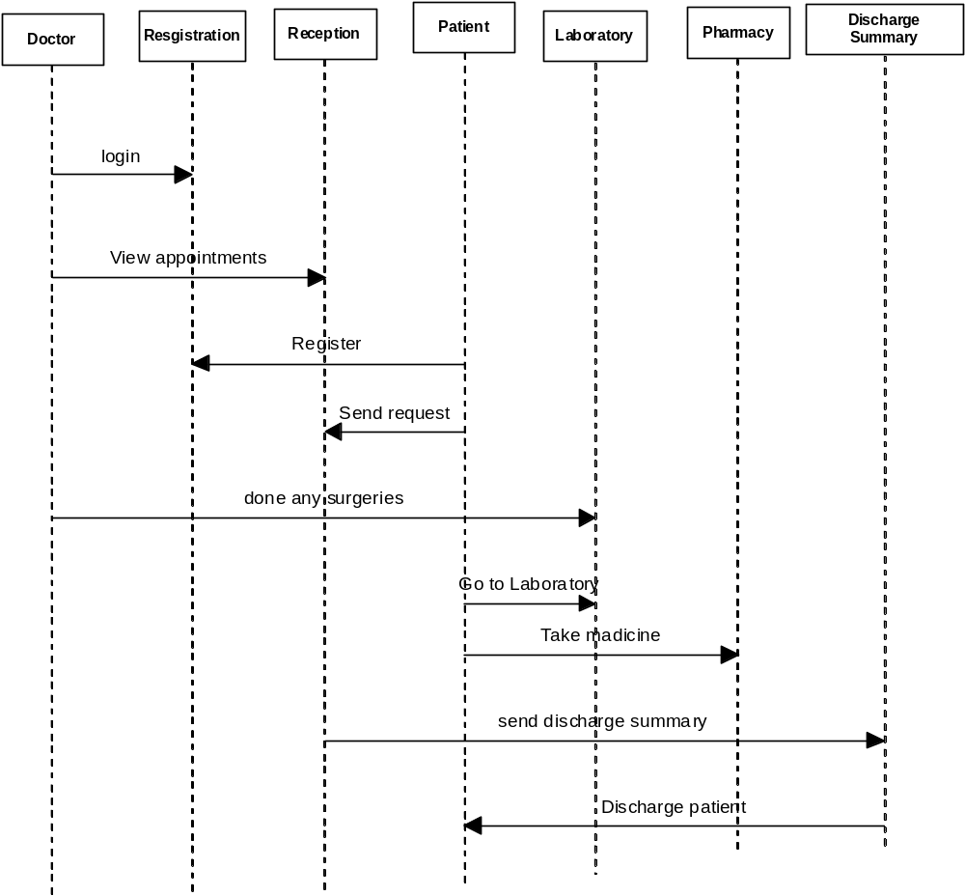

COLLABORATION DIAGRAM:

A collaboration diagram is an introduction diagram that emphasizes the structural organization of the objects that send and receive messages. Graphically a collaboration diagram is a collection of vertices and arcs.

CLASS DIAGRAM:
Class is nothing but a structure that contains both variables and methods. The Class Diagram shows a set of classes, interfaces, and collaborations and their relating ships. There is most common diagram in modeling the object oriented systems and are used to give the static view of a system. It shows the dependency between the classes that can be used in our system.
The interactions between the modules or classes of our projects are shown below. Each block contains Class Name, Variables and Methods.

Activity Diagram

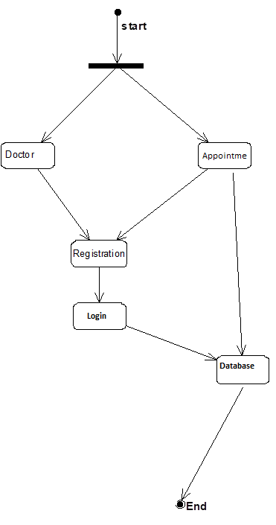

DATA FLOW DIAGRAMS:

The DFD takes an input-process-output view of a system i.e. data objects flow into the software, are transformed by processing elements, and resultant data objects flow out of the software.

Data objects represented by labeled arrows and transformation are represented by circles also called as bubbles. DFD is presented in a hierarchical fashion i.e. the first data flow model represents the system as a whole. Subsequent DFD refine the context diagram (level 0 DFD), providing increasing details with each subsequent level.

The DFD enables the software engineer to develop models of the information domain & functional domain at the same time. As the DFD is refined into greater levels of details, the analyst perform an implicit functional decomposition of the system. At the same time, the DFD refinement results in a corresponding refinement of the data as it moves through the process that embody the applications.

A context-level DFD for the system the primary external entities produce information for use by the system and consume information generated by the system. The labeled arrow represents data objects or object hierarchy.

RULES FOR DFD:

- Fix the scope of the system by means of context diagrams.

- Organize the DFD so that the main sequence of the actions

- Reads left to right and top to bottom.

- Identify all inputs and outputs.

- Identify and label each process internal to the system with Rounded circles.

- A process is required for all the data transformation and Transfers. Therefore, never connect a data store to a data Source or the destinations or another data store with just a Data flow arrow.

- Do not indicate hardware and ignore control information.

- Make sure the names of the processes accurately convey everything the process is done.

- There must not be unnamed process.

- Indicate external sources and destinations of the data, with Squares.

- Number each occurrence of repeated external entities.

- Identify all data flows for each process step, except simple Record retrievals.

- Label data flow on each arrow.

- Use details flow on each arrow.

- Use the details flow arrow to indicate data movements.

E-R Diagrams:
The Entity-Relationship (ER) model was originally proposed by Peter in 1976 [Chen76] as a way to unify the network and relational database views. Simply stated the ER model is a conceptual data model that views the real world as entities and relationships. A basic component of the model is the Entity-Relationship diagram which is used to visually represents data objects. Since Chen wrote his paper the model has been extended and today it is commonly used for database design For the database designer, the utility of the ER model is:
- it maps well to the relational model. The constructs used in the ER model can easily be transformed into relational tables.
- it is simple and easy to understand with a minimum of training. Therefore, the model can be used by the database designer to communicate the design to the end user.
- In addition, the model can be used as a design plan by the database developer to implement a data model in a specific database management software.

Connectivity and Cardinality
The basic types of connectivity for relations are: one-to-one, one-to-many, and many-to-many. A one-to-one (1:1) relationship is when at most one instance of a entity A is associated with one instance of entity B. For example, "employees in the company are each assigned their own office. For each employee there exists a unique office and for each office there exists a unique employee.
A one-to-many (1:N) relationships is when for one instance of entity A, there are zero, one, or many instances of entity B, but for one instance of entity B, there is only one instance of entity A. An example of a 1:N relationships is
a department has many employees
each employee is assigned to one department
A many-to-many (M:N) relationship, sometimes called non-specific, is when for one instance of entity A, there are zero, one, or many instances of entity B and for one instance of entity B there are zero, one, or many instances of entity A. The connectivity of a relationship describes the mapping of associated

ER Notation
There is no standard for representing data objects in ER diagrams. Each modeling methodology uses its own notation. The original notation used by Chen is widely used in academics texts and journals but rarely seen in either CASE tools or publications by non-academics. Today, there are a number of notations used, among the more common are Bachman, crow's foot, and IDEFIX.
All notational styles represent entities as rectangular boxes and relationships as lines connecting boxes. Each style uses a special set of symbols to represent the cardinality of a connection. The notation used in this document is from Martin. The symbols used for the basic ER constructs are:
- entities are represented by labeled rectangles. The label is the name of the entity. Entity names should be singular nouns.
- relationships are represented by a solid line connecting two entities. The name of the relationship is written above the line. Relationship names should be verbs
- attributes, when included, are listed inside the entity rectangle. Attributes which are identifiers are underlined. Attribute names should be singular nouns.
- cardinality of many is represented by a line ending in a crow's foot. If the crow's foot is omitted, the cardinality is one.
- existence is represented by placing a circle or a perpendicular bar on the line. Mandatory existence is shown by the bar (looks like a 1) next to the entity for an instance is required. Optional existence is shown by placing a circle next to the entity that is optional
MODULES

PROJECT MODULES

- Reception
- Administration
- Pharmacy
- Laboratory
- Registration
- Discharge Summary

MODULE DESCRIPTION

Name of the module-1: Welcome

Description: The reception module handles various enquiries about the patient's admission and discharge details, bed census, and the patient's movements within the hospital. The system can also handle fixed-cost package deals for patients as well as Doctor Consultation and Scheduling, Doctor Consultancy Fees and Time Allocation
Sub modules:
- Make an Appointment
- Doctor login/Registration
- Appointment Fetch

Name of the module-2: Administration

Description: This module handles all the master entry details for the hospital requirement such as consultation detail, doctor specialization, consultancy fee, and service charges.
Employee

Sub modules:
- Employee Detail Recording.
- Doctor Type .
- Doctor Master
- Referral Doctor

Name of the module-3: Pharmacy
Description: This module deals with all medical items. This module helps in maintaining Item Master, Receipt of Drugs/consumables, issue, handling of material return, generating retail bills, stock maintenance. It also helps in fulfilling the requirements of both IPD and OPD Pharmacy.

Name of the module-4: Laboratory.
Description: This module enables the maintenance of investigation requests by the patient and generation of test results for the various available services, such as clinical pathology, X-ray and ultrasound tests. Requests can be made from various points, including wards, billing, sample collection and the laboratory receiving point. The laboratory module is integrated with the in-patient/ outpatient registration, wards and billing modules.

Name of the module-5: Registration.
Description: This module helps in registering information about patients and handling both IPD and OPD patient’s query. A unique ID is generated for each patient after registration. This helps in implementing customer relationship management and also maintains medical history of the patient.

Name of the module-6: Discharge Summary.
Description: The module helps in generating patient’s discharge summary, which includes patient’s health at the time of discharge, medical history, various diagnosis and drug prescriptions, history of present illness and course in hospital.

IMPLEMENTATION

OVERVIEW OF TECHNOLOGIES USED

3.1 Front End Technology

Html
The Html is a new computing platform that simplifies application development in the highly distributed environment of the Internet. The Html is designed to fulfill the following objectives:
- To provide a consistent object-oriented programming environment whether object code is stored and executed locally, executed locally but Internet-distributed, or executed remotely.
- To provide a code-execution environment that minimizes software deployment and versioning conflicts.
- To provide a code-execution environment that guarantees safe execution of code, including code created by an unknown or semi-trusted third party.
- To provide a code-execution environment that eliminates the performance problems of scripted or interpreted environments.
- To make the developer experience consistent across widely varying types of applications, such as Windows-based applications and Web-based applications.
- To build all communication on industry standards to ensure that code based on the Html can integrate with any other code.
The Html has two main components: the common language runtime and the Html class library. The common language runtime is the foundation of the Html . You can think of the runtime as an agent that manages code at execution time, providing core services such as memory management, thread management, and remoting , while also enforcing strict type safety and other forms of code accuracy that ensure security and robustness. In fact, the concept of code management is a fundamental principle of the runtime. Code that targets the runtime is known as managed code, while code that does not target the runtime is known as unmanaged code. The class library, the other main component of the Html , is a comprehensive, object-oriented collection of reusable types that you can use to develop applications ranging from traditional command-line or graphical user interface (GUI) applications to applications based on the latest innovations provided by PHP, such as Web Forms and XML Web services.
The Html can be hosted by unmanaged components that load the common language runtime into their processes and initiate the execution of managed code, thereby creating a software environment that can exploit both managed and unmanaged features. The Html not only provides several runtime hosts, but also supports the development of third-party runtime hosts.
For example, PHP hosts the runtime to provide a scalable, server-side environment for managed code. PHP works directly with the runtime to enable Web Forms applications and XML Web services, both of which are discussed later in this topic.
Internet Explorer is an example of an unmanaged application that hosts the runtime (in the form of a MIME type extension). Using Internet Explorer to host the runtime enables you to embed managed components or Windows Forms controls in HTML documents. Hosting the runtime in this way makes managed mobile code (similar to Microsoft® ActiveX® controls) possible, but with significant improvements that only managed code can offer, such as semi-trusted execution and secure isolated file storage.
The following illustration shows the relationship of the common language runtime and the class library to your applications and to the overall system. The illustration also shows how managed code operates within a larger architecture.

Features of the Common Language Runtime
The common language runtime manages memory, thread execution, code execution, code safety verification, compilation, and other system services. These features are intrinsic to the managed code that runs on the common language runtime.
With regards to security, managed components are awarded varying degrees of trust, depending on a number of factors that include their origin (such as the Internet, enterprise network, or local computer). This means that a managed component might or might not be able to perform file-access operations, registry-access operations, or other sensitive functions, even if it is being used in the same active application.
The runtime enforces code access security. For example, users can trust that an executable embedded in a Web page can play an animation on screen or sing a song, but cannot access their personal data, file system, or network. The security features of the runtime thus enable legitimate Internet-deployed software to be exceptionally featuring rich.
The runtime also enforces code robustness by implementing a strict type- and code-verification infrastructure called the common type system (CTS). The CTS ensures that all managed code is self-describing. The various Microsoft and third-party language compilers generate managed code that conforms to the CTS. This means that managed code can consume other managed types and instances, while strictly enforcing type fidelity and type safety.
In addition, the managed environment of the runtime eliminates many common software issues. For example, the runtime automatically handles object layout and manages references to objects, releasing them when they are no longer being used. This automatic memory management resolves the two most common application errors, memory leaks and invalid memory references.
The runtime also accelerates developer productivity. For example, programmers can write applications in their development language of choice, yet take full advantage of the runtime, the class library, and components written in other languages by other developers. Any compiler vendor who chooses to target the runtime can do so. Language compilers that target the Html make the features of the Html available to existing code written in that language, greatly easing the migration process for existing applications.
While the runtime is designed for the software of the future, it also supports software of today and yesterday. Interoperability between managed and unmanaged code enables developers to continue to use necessary COM components and DLLs.
The runtime is designed to enhance performance. Although the common language runtime provides many standard runtime services, managed code is never interpreted. A feature called just-in-time (JIT) compiling enables all managed code to run in the native machine language of the system on which it is executing. Meanwhile, the memory manager removes the possibilities of fragmented memory and increases memory locality-of-reference to further increase performance.
Finally, the runtime can be hosted by high-performance, server-side applications, such as Microsoft® MYSQL Server™ and Internet Information Services (IIS). This infrastructure enables you to use managed code to write your business logic, while still enjoying the superior performance of the industry's best enterprise servers that support runtime hosting.

Html Class Library
The Html class library is a collection of reusable types that tightly integrate with the common language runtime. The class library is object oriented, providing types from which your own managed code can derive functionality. This not only makes the Html types easy to use, but also reduces the time associated with learning new features of the Html . In addition, third-party components can integrate seamlessly with classes in the Html .
For example, the Html collection classes implement a set of interfaces that you can use to develop your own collection classes. Your collection classes will blend seamlessly with the classes in the Html .
As you would expect from an object-oriented class library, the Html types enable you to accomplish a range of common programming tasks, including tasks such as string management, data collection, database connectivity, and file access. In addition to these common tasks, the class library includes types that support a variety of specialized development scenarios. For example, you can use the Html to develop the following types of applications and services:
- Console applications.
- Scripted or hosted applications.
- Windows GUI applications (Windows Forms).
- PHP applications.
- XML Web services.
- Windows services.
For example, the Windows Forms classes are a comprehensive set of reusable types that vastly simplify Windows GUI development. If you write an PHP Web Form application, you can use the Web Forms classes.

Client Application Development
Client applications are the closest to a traditional style of application in Windows-based programming. These are the types of applications that display windows or forms on the desktop, enabling a user to perform a task. Client applications include applications such as word processors and spreadsheets, as well as custom business applications such as data-entry tools, reporting tools, and so on. Client applications usually employ windows, menus, buttons, and other GUI elements, and they likely access local resources such as the file system and peripherals such as printers.
Another kind of client application is the traditional ActiveX control (now replaced by the managed Windows Forms control) deployed over the Internet as a Web page. This application is much like other client applications: it is executed natively, has access to local resources, and includes graphical elements.
In the past, developers created such applications using C/C++ in conjunction with the Microsoft Foundation Classes (MFC) or with a rapid application development (RAD) environment such as Microsoft® Visual Basic®. The Html incorporates aspects of these existing products into a single, consistent development environment that drastically simplifies the development of client applications. The Windows Forms classes contained in the Html are designed to be used for GUI development. You can easily create command windows, buttons, menus, toolbars, and other screen elements with the flexibility necessary to accommodate shifting business needs.
For example, the Html provides simple properties to adjust visual attributes associated with forms. In some cases the underlying operating system does not support changing these attributes directly, and in these cases the Html automatically recreates the forms. This is one of many ways in which the Html integrates the developer interface, making coding simpler and more consistent.
Unlike ActiveX controls, Windows Forms controls have semi-trusted access to a user's computer. This means that binary or natively executing code can access some of the resources on the user's system (such as GUI elements and limited file access) without being able to access or compromise other resources. Because of code access security, many applications that once needed to be installed on a user's system can now be safely deployed through the Web. Your applications can implement the features of a local application while being deployed like a Web page.

Server Application Development
Server-side applications in the managed world are implemented through runtime hosts. Unmanaged applications host the common language runtime, which allows your custom managed code to control the behavior of the server. This model provides you with all the features of the common language runtime and class library while gaining the performance and scalability of the host server.
The following illustration shows a basic network schema with managed code running in different server environments. Servers such as IIS and MYSQL Server can perform standard operations while your application logic executes through the managed code.
Server-side managed code
PHP is the hosting environment that enables developers to use the Html to target Web-based applications. However, PHP is more than just a runtime host; it is a complete architecture for developing Web sites and Internet-distributed objects using managed code. Both Web Forms and XML Web services use IIS and PHP as the publishing mechanism for applications, and both have a collection of supporting classes in the Html .
XML Web services, an important evolution in Web-based technology, are distributed, server-side application components similar to common Web sites. However, unlike Web-based applications, XML Web services components have no UI and are not targeted for browsers such as Internet Explorer and Netscape Navigator. Instead, XML Web services consist of reusable software components designed to be consumed by other applications, such as traditional client applications, Web-based applications, or even other XML Web services. As a result, XML Web services technology is rapidly moving application development and deployment into the highly distributed environment of the Internet.
If you have used earlier versions of ASP technology, you will immediately notice the improvements that PHP and Web Forms offers. For example, you can develop Web Forms pages in any language that supports the Html . In addition, your code no longer needs to share the same file with your HTTP text (although it can continue to do so if you prefer). Web Forms pages execute in native machine language because, like any other managed application, they take full advantage of the runtime. In contrast, unmanaged ASP pages are always scripted and interpreted. PHP pages are faster, more functional, and easier to develop than unmanaged ASP pages because they interact with the runtime like any managed application.
The Html also provides a collection of classes and tools to aid in development and consumption of XML Web services applications. XML Web services are built on standards such as SOAP (a remote procedure-call protocol), XML (an extensible data format), and WSDL ( the Web Services Description Language). The Html is built on these standards to promote interoperability with non-Microsoft solutions.
For example, the Web Services Description Language tool included with the Html SDK can query an XML Web service published on the Web, parse its WSDL description, and produce C# or Visual Basic source code that your application can use to become a client of the XML Web service. The source code can create classes derived from classes in the class library that handle all the underlying communication using SOAP and XML parsing. Although you can use the class library to consume XML Web services directly, the Web Services Description Language tool and the other tools contained in the SDK facilitate your development efforts with the Html .
If you develop and publish your own XML Web service, the Html provides a set of classes that conform to all the underlying communication standards, such as SOAP, WSDL, and XML. Using those classes enables you to focus on the logic of your service, without concerning yourself with the communications infrastructure required by distributed software development.
Finally, like Web Forms pages in the managed environment, your XML Web service will run with the speed of native machine language using the scalable communication of IIS.
Active Server PagesHtml
PHP is a programming built on the common language runtime that can be used on a server to build powerful Web applications. PHP offers several important advantages over previous Web development models:
- Enhanced Performance. PHP is compiled common language runtime code running on the server. Unlike its interpreted predecessors, PHP can take advantage of early binding, just-in-time compilation, native optimization, and caching services right out of the box. This amounts to dramatically better performance before you ever write a line of code.
- World-Class Tool Support. The PHP is complemented by a rich toolbox and designer in the Visual Studio code integrated development environment. WYSIWYG editing, drag-and-drop server controls, and automatic deployment are just a few of the features this powerful tool provides.
- Power and Flexibility. Because PHP is based on the common language runtime, the power and flexibility of that entire platform is available to Web application developers. The Html class library, Messaging, and Data Access solutions are all seamlessly accessible from the Web. PHP is also language-independent, so you can choose the language that best applies to your application or partition your application across many languages. Further, common language runtime interoperability guarantees that your existing investment in COM-based development is preserved when migrating to PHP.
- Simplicity. PHP makes it easy to perform common tasks, from simple form submission and client authentication to deployment and site configuration. For example, the PHP page allows you to build user interfaces that cleanly separate application logic from presentation code and to handle events in a simple, Visual Basic - like forms processing model. Additionally, the common language runtime simplifies development, with managed code services such as automatic reference counting and garbage collection.
- Manageability. PHP employs a text-based, hierarchical configuration system, which simplifies applying settings to your server environment and Web applications. Because configuration information is stored as plain text, new settings may be applied without the aid of local administration tools. This "zero local administration" philosophy extends to deploying PHP applications as well. An PHP application is deployed to a server simply by copying the necessary files to the server. No server restart is required, even to deploy or replace running compiled code.
- Scalability and Availability. PHP has been designed with scalability in mind, with features specifically tailored to improve performance in clustered and multiprocessor environments. Further, processes are closely monitored and managed by the PHP runtime, so that if one misbehaves (leaks, deadlocks), a new process can be created in its place, which helps keep your application constantly available to handle requests.
- Customizability and Extensibility. PHP delivers a well-factored architecture that allows developers to "plug-in" their code at the appropriate level. In fact, it is possible to extend or replace any subcomponent of the PHP runtime with your own custom-written component. Implementing custom authentication or state services has never been easier.
- Security. With built in Windows authentication and per-application configuration, you can be assured that your applications are secure.

Language Support

The Microsoft Html Platform currently offers built-in support for three languages: C#, Visual Basic, and Jscript .

What is PHP Web Forms?
The PHP Web Forms page is a scalable common language runtime programming model that can be used on the server to dynamically generate Web pages.
Intended as a logical evolution of ASP (PHP provides syntax compatibility with existing pages), the PHP Web Forms has been specifically designed to address a number of key deficiencies in the previous model. In particular, it provides:
- The ability to create and use reusable UI controls that can encapsulate common functionality and thus reduce the amount of code that a page developer has to write.
- The ability for developers to cleanly structure their page logic in an orderly fashion (not "spaghetti code").
- The ability for development tools to provide strong WYSIWYG design support for pages (existing ASP code is opaque to tools).
PHP Web Forms pages are text files with an .php file name extension. They can be deployed throughout an IIS virtual root directory tree. When a browser client requests .php resources, the PHP runtime parses and compiles the target file into a Html class. This class can then be used to dynamically process incoming requests. (Note that the .php file is compiled only the first time it is accessed; the compiled type instance is then reused across multiple requests).
An PHP page can be created simply by taking an existing HTML file and changing its file name extension to .php (no modification of code is required). For example, the following sample demonstrates a simple HTML page that collects a user's name and category preference and then performs a form post back to the originating page when a button is clicked:
PHP provides syntax compatibility with existing ASP pages. This includes support for <% %> code render blocks that can be intermixed with HTML content within an .php file. These code blocks execute in a top-down manner at page render time.

Code-Behind Web Forms
PHP supports two methods of authoring dynamic pages. The first is the method shown in the preceding samples, where the page code is physically declared within the originating .php file. An alternative approach--known as the code-behind method--enables the page code to be more cleanly separated from the HTML content into an entirely separate file.

3.2 BACK END TECHNOLOGY:
ABOUT PHP Myadmin

- phpMyAdmin is a free software tool written in PHP, intended to handle the administration of MySQL over the Web. phpMyAdmin supports a wide range of operations on MySQL and MariaDB. Frequently used operations (managing databases, tables, columns, relations, indexes, users, permissions, etc) can be performed via the user interface, while you still have the ability to directly execute any SQL statement.
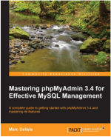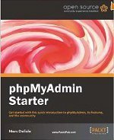
- phpMyAdmin comes with a wide range of documentation and users are welcome to update our wiki pages to share ideas and howtos for various operations. The phpMyAdmin team will try to help you if you face any problem; you can use a variety of support channels to get help.
- phpMyAdmin is also very deeply documented in a book written by one of the developers – Mastering phpMyAdmin for Effective MySQL Management, which is available in English and Spanish.
- To ease usage to a wide range of people, phpMyAdmin is being translated into 72 languages and supports both LTR and RTL languages.
- phpMyAdmin is a mature project with a stable and flexible code base; you can find out more about the project and its history and the awards it earned. When the project turned 15, we published a celebration page.
- The phpMyAdmin project is a member of Software Freedom Conservancy. SFC is a not-for-profit organization that helps promote, improve, develop, and defend Free, Libre, and Open Source Software (FLOSS) projects.

Features
- Intuitive web interface
- Support for most MySQL features:
  - browse and drop databases, tables, views, fields and indexes
  - create, copy, drop, rename and alter databases, tables, fields and indexes
  - maintenance server, databases and tables, with proposals on server configuration
  - execute, edit and bookmark any SQL-statement, even batch-queries
  - manage MySQL user accounts and privileges
  - manage stored procedures and triggers
- Import data from CSV and SQL
- Export data to various formats: CSV, SQL, XML, PDF, ISO/IEC 26300 - OpenDocument Text and Spreadsheet, Word, L^{A}T_{E}X and others
- Administering multiple servers
- Creating graphics of your database layout in various formats
- Creating complex queries using Query-by-example (QBE)
- Searching globally in a database or a subset of it
- Transforming stored data into any format using a set of predefined functions, like displaying BLOB-data as image or download-link
- And much more..

PHP FILE HANDLING

PHP readfile() Function

PHP readfile() Function
The readfile() function reads a file and writes it to the output buffer.
Assume we have a text file called "webdictionary.txt", stored on the server, that looks like this:
AJAX = Asynchronous JavaScript and XML
CSS = Cascading Style Sheets
HTML = Hyper Text Markup Language
PHP = PHP Hypertext Preprocessor
MYSQL = Structured Query Language
SVG = Scalable Vector Graphics
XML = EXtensible Markup Language
The PHP code to read the file and write it to the output buffer is as follows (the readfile() function returns the number of bytes read on success):

Example
<?php
echo readfile("webdictionary.txt");
?>

Connections
Connections are used to 'talk to' databases, and are represented by provider-specific classes such as MYSQLConnection. Commands travel over connections and result sets are returned in the form of streams which can be read by a Data Reader object, or pushed into a Dataset object.
Commands
Commands contain the information that is submitted to a database, and are represented by provider-specific classes such as MYSQLCommand. A command can be a stored procedure call, an UPDATE statement, or a statement that returns results. You can also use input and output parameters, and return values as part of your command syntax. The example below shows how to issue an INSERT statement against the North wind database.
Data Readers
The Data Reader object is somewhat synonymous with a read-only/forward-only cursor over data. The Data Reader API supports flat as well as hierarchical data. A Data Reader object is returned after executing a command against a database. The format of the returned Data Reader object is different from a record set. For example, you might use the Data Reader to show the results of a search list in a web page.
Datasets
The Dataset object is similar to the ADO Record set object, but more powerful, and with one other important distinction: the Dataset is always disconnected. The Dataset object represents a cache of data, with database-like structures such as tables, columns, relationships, and constraints. However, though a Dataset can and does behave much like a database, it is important to remember that Dataset objects do not interact directly with databases, or other source data. This allows the developer to work with a programming model that is always consistent, regardless of where the source data resides. Data coming from a database, an XML file, from code, or user input can all be placed into Dataset objects. Then, as changes are made to the Dataset they can be tracked and verified before updating the source data. The Get Changes method of the Dataset object actually creates a second Dataset that contains only the changes to the data. This Dataset is then used by a Data Adapter (or other objects) to update the original data source. The Dataset has many XML characteristics, including the ability to produce and consume XML data and XML schemas. XML schemas can be used to describe schemas interchanged via Web Services. In fact, a Dataset with a schema can actually be compiled for type safety and statement completion.
Php Connections
Before we can access data in the MyMYSQL database, we need to be able to connect to the server:

Example (MyMYSQLi Object-Oriented)
<?php
$servername = "localhost";
$username = "username";
$password = "password";
// Create connection
$conn = new myMySQLi($servername, $username, $password);
// Check connection
if ($conn->connect_error) {
die("Connection failed: " . $conn->connect_error);
}
echo "Connected successfully";
?
Client-side Script(JAVASCRIPT):-

JavaScript:

JavaScript is a new scripting language for WebPages. Scripts written with java script can be embedded into your HTML pages. With java script you have many possibilities for enhancing your HTML page with interesting elements. For example you are able to respond to user-initiated events quite easily. Some effects that are now possible with java script were some time ago only possible with CGI. So you can create really sophisticated pages with the helps of java script on the Internet.
How can Java Script scripts run?

The first browser to support java script was the Netscape Navigator 2.0 of course the higher versions do have java script as well. You might know that java does not run on all Netscape Navigators 2.0 (or higher versions) versions. But this is not true for java script -although there are some problems with the different versions.
The Mac version for example seems to have many bugs. In the near future there are going to be some other browsers, which support java script. The Microsoft Internet explorer 3.0 is going to support java script. JavaScript enabled browsers are going to spread soon - it is worth learning this new technique now. You might realize that is really easy to write Java Script scripts. We have to know is some basic techniques and some work-around for problems you might encounter. Of course we need a basic. Understanding HTML before reading this tutorial you can find many really good online resources about HTML. Best you make an online search about ‘html’ at yahoo if you want to get informed about HTML. Now I want to show some small scripts so you can learn how they are implemented into HTML-documents and to show which possibilities you have with the new scripting language. The following is a very small script, which will only print a text into an HTML document.
<html>
<head>
My first JavaScript
</head>
<body><br>
This is a normal HTML document
<br>
<script language=”JavaScript”>
Document.write (“this is a java script”)
</script><b r>
Backing HTML again
</body>
</html>
If you are using a java script enabled-browser at the moment then you will have the possibility to see this script working. If your browser doesn’t support Java Script then this output might be some kind of strange…
This is a normal HTML document
This is java script!
Back in HTML again.

FUNCTIONS

Functions are bet declared between the <Head> tag of HTML page. Functions are called by user-initiated events. Seems reasonable to keep the functions between the <Head> tags. They are loaded first before a user can do anything that might call a function. Scripts can be placed between inside comment fields to ensure that older browser do not display the script itself.

<html>
<head>
<script language=”JavaScript”>
function pushbutton (){
alert (“Hello!”);
}
</script>
</head>
<body>
<form>
<input type=”button” name=”Button1” value=”push me” onclick=”pushbutton ()”>
</form>
</body>
</html>

If we want to test this one immediately and you are using a Java Script enabled browser then please go ahead and push the button.
This script will create a button and when you press it a window will pop up saying “hello!”. In fact we have a lot of possibilities just by adding functions to our scripts.
The common browsers transmit the form information by either method: here’s the complete tag including the GET transmission method attribute for the previous form

Example:

<Form method =GET action=http://www.mycompany.com/cgi-bin/upfdate.pl>
………
</form>

Input elements.

Use the <input> tag to define any one of a number of common form elements including text fields multiple choice lists click able images and submission buttons. There are many attributers for this tag only that types and name attributes are required for each element, each type of input element uses only a subset of the followed attributes. Additional <input> attributes may be required based upon which type of the form element you specify.

Submit button:

The submit button (<input type=submit> ) does what its name implies, settings in motion the form’s submission to the server from the browser. We many have more than submit buttons will be added to the parameter list the browser sends along to the server.

Example
< Input type =”submit”>
<Input type=”submit” value=”submit” name=”name”>

Reset button:

The reset button if firm <input> button is nearly self- explanatory; it lets the user reset erase or set to some default value all elements in the form. By default the browser displays a reset button worth the label “reset”. We can change that by specifying a value attribute with tour own button label.

DATABASE MODELS

ADOHtml and accessing the database through applets and ADOHtml API via an intermediate server resulted server resulted in a new type of database model which is different from the client-server model. Based on number of intermediate server through the request should go it is named as single tire, two tire and multi tire architecture

Single Tier

In a single tier the server and client are the same in the sense that a client program that needs information (client) and the source of this type of architecture is also possible in java, in case flat files are used to store the data. However this is useful only in case of small applications. The advantage with this is the simplicity and portability of the application developed.
Server and client

Database

Two Tier (client-server)

In two tier architecture the database resides in one machine and client in different machine they are connected through the network. In this type of architecture a database management takes control of the database and provides access to clients in a network. This software bundle is also called as the server. Software in different machines, requesting for information are called as the clients.

Server

Client

Client

Database

Three Tier and N-Tier

In the three-tier architecture, any number servers can access the database that resides on server. Which in turn serve clients in a network. For example, you want to access the database using java applets, the applet running in some other machine, can send request only to the server from which it is down loaded. For this reason we will need to have a intermediate server which will accept the requests from applets and them to the actual database server. This intermediate server acts as a two-way communication channel also. This is the information or data from the database is passed on to the applet that is requesting it. This can be extended to make n tiers of servers, each server carrying to specific type of request from clients, however in practice only 3 tiers architecture is popular.

PHP Language
PHP (recursive acronym for PHP: Hypertext Preprocessor) is a widely-used open source general-purpose scripting language that is especially suited for web development and can be embedded into HTML.
- Nice, but what does that mean? An example:
Example #1 An introductory example
<!DOCTYPE html>
<html>
<head>
<title>Example</title>
</head>
<body>
<?php
echo "Hi, I'm a PHP script!";
?>
</body>
</html>
- Instead of lots of commands to output HTML (as seen in C or Perl), PHP pages contain HTML with embedded code that does "something" (in this case, output "Hi, I'm a PHP script!"). The PHP code is enclosed in special start and end processing instructions <?php and ?> that allow you to jump into and out of "PHP mode."
- What distinguishes PHP from something like client-side JavaScript is that the code is executed on the server, generating HTML which is then sent to the client. The client would receive the results of running that script, but would not know what the underlying code was. You can even configure your web server to process all your HTML files with PHP, and then there's really no way that users can tell what you have up your sleeve.
- The best things in using PHP are that it is extremely simple for a newcomer, but offers many advanced features for a professional programmer. Don't be afraid reading the long list of PHP's features. You can jump in, in a short time, and start writing simple scripts in a few hours.
- Although PHP's development is focused on server-side scripting, you can do much more with it. Read on, and see more in the What can PHP do? section, or go right to the introductory tutorial if you are only interested in web programming.

History:-

PHP development began in 1994 when Rasmus Lerdorf wrote several Common Gateway Interface (CGI) programs in C which he used to maintain his personal homepage.
He extended them to work with web forms and to communicate with databases, and called this implementation "Personal Home Page/Forms Interpreter" or PHP/FI.
PHP/FI could be used to build simple, dynamic web applications. To accelerate bug reporting and improve the code, Lerdorf initially announced the release of PHP/FI as "Personal Home Page Tools (PHP Tools) version 1.0" on the Usenet discussion group comp.infosystems.www.authoring.cgi on June 8, 1995.
This release already had the basic functionality that PHP has today. This included Perl-like variables, form handling, and the ability to embed HTML. The syntax resembled that of Perl, but was simpler, more limited and less consistent.

Features of C#:-
PHP received mixed reviews due to lacking native Unicode support at the core language level. In 2005, a project headed by Andrei Zmievski was initiated to bring native Unicode support throughout PHP, by embedding the International Components for Unicode (ICU) library, and representing text strings as UTF-16 internally. Since this would cause major changes both to the internals of the language and to user code, it was planned to release this as version 6.0 of the language, along with other major features then in development..
Some notable PHP distinguishing features are:
- Many fatal- or recoverable-level legacy PHP error mechanisms were replaced with modern object-oriented
- The syntax for variable dereferencing was reworked to be internally more consistent and complete, allowing the use of the operators ->, [], (),{}, and ::, with arbitrary meaningful left-side expressions.
- Support for legacy PHP 4-style constructor methods was deprecated.
- Constructors for the few classes built-in to PHP which returned null upon failure were changed to throw an exception instead, for consistency.
- Several unmaintained or deprecated server application programming interfaces (SAPIs) and extensions were removed from the PHP core, most notably the legacy myMySQL extension.
- The behavior of the list() operator was changed to remove support for strings.
- Support was removed for legacy ASP-style delimiters <% and %> and <script language="php"> ... </script>.
- An oversight allowing a switch statement to have multiple default clauses was fixed
- Support for hexadecimal number support in some implicit conversions from strings to number types was removed.
- The left-shift and right-shift operators were changed to behave more consistently across platforms.
- Conversions between floating-point numbers and integers were changed (e.g. infinity changed to convert to zero) and implemented more consistently across platforms.

Categories of datatypes
CTS separates datatypes into two categories:
- Value types
- Reference types
Value types are plain aggregations of data. Instances of value types do not have referential identity nor a referential comparison semantics - equality and inequality comparisons for value types compare the actual data values within the instances, unless the corresponding operators are overloaded. Value types are derived from System.ValueType, always have a default value, and can always be created and copied. Some other limitations on value types are that they cannot derive from each other (but can implement interfaces) and cannot have a default (parameterless) constructor. Examples of value types are some primitive types, such as int (a signed 32-bit integer), float (a 32-bit IEEE floating-point number), char (a 16-bit Unicode codepoint), and System.DateTime (identifies a specific point in time with millisecond precision).
In contrast, reference types have the notion of referential identity - each instance of reference type is inherently distinct from every other instance, even if the data within both instances is the same. This is reflected in default equality and inequality comparisons for reference types, which test for referential rather than structural equality, unless the corresponding operators are overloaded (such as the case for System.String). In general, it is not always possible to create an instance of a reference type, nor to copy an existing instance, or perform a value comparison on two existing instances, though specific reference types can provide such services by exposing a public constructor or implementing a corresponding interface (such as ICloneable or IComparable). Examples of reference types are object (the ultimate base class for all other C# classes), System.String (a string of Unicode characters), and System.Array (a base class for all C# arrays).
Both type categories are extensible with user-defined types.

Syntax
- The following "Hello, World!" program is written in PHP code embedded in an HTML document:
<!DOCTYPE html>
<html>
<head>
<title>PHP "Hello, World!" program</title>
</head>
<body>
<?php
echo '<p>Hello, World!</p>';
?>
</body>
</html>
- However, as no requirement exists for PHP code to be embedded in HTML, the simplest version of Hello, World! may be written like this, with the closing tag omitted as preferred in files containing pure PHP code^{[146]}
<?php
echo 'Hello, World!';
?>

Functions
- PHP defines a large array of functions in the core language and many are also available in various extensions; these functions are well documented in the online PHP documentation.^{[161]} However, the built-in library has a wide variety of naming conventions and associated inconsistencies, as described under history above.
- Custom functions may be defined by the developer:
function myAge(int $birthYear): string
{
// calculate the age by subtracting the birth year from the current year.
$yearsOld = date('Y') - $birthYear;

// return the age in a descriptive string.
return $yearsOld . ' year' . ($yearsOld != 1 ? 's':'');
}

echo 'I am currently ' . myAge(1995) . ' old.';

DATABASE TABLES

DATABASE TABLES:

Doctor Registration

Name | NULL / NOTNULL | TYPE | KEY
Name | Null | Varchar (20)
Loginid | Null | Varchar(20) | PRIMARY KEY
Createdat | Null | Varchar(20)

Patient Appointment

Name | NULL / NOTNULL | TYPE | KEY
Name | Null | Varchar (20)
Loginid | Null | Varchar(20) | PRIMARY KEY
age | Null | INT(20)
gender | Null | Varchar(20)
Phonenumber | Null | INT(20)
Others | Null | Varchar(20)
Email | Null | Varchar(20)
Date | Null | DATETIME

FEASIBILITY STUDY:

Feasibility study is conducted once the problem is clearly understood. Feasibility study is a high level capsule version of the entire system analysis and design process. The objective is to determine quickly at a minimum expense how to solve a problem. The purpose of feasibility is not to solve the problem but to determine if the problem is worth solving.

The system has been tested for feasibility in the following points.
1. Technical Feasibility
2. Economical Feasibility
3. Operational Feasibility.

1. TECHNICAL FEASIBILITY
The project entitles "Courier Service System” is technically feasibility because of the below mentioned feature. The project was developed in Java which Graphical User Interface.
It provides the high level of reliability, availability and compatibility. All these make Java an appropriate language for this project. Thus the existing software Java is a powerful language.

2. ECONOMICAL FEASIBILITY

The computerized system will help in automate the selection leading the profits and details of the organization. With this software, the machine and manpower utilization are expected to go up by 80-90% approximately. The costs incurred of not creating the system are set to be great, because precious time can be wanted by manually.

3. OPERATIONAL FEASIBILITY

In this project, the management will know the details of each project where he may be presented and the data will be maintained as decentralized and if any inquires for that particular contract can be known as per their requirements and necessaries.

IMPLEMENTATION:

Implementation is the stage where the theoretical design is turned into a working system. The most crucial stage in achieving a new successful system and in giving confidence on the new system for the users that it will work efficiently and effectively.

The system can be implemented only after thorough testing is done and if it is found to work according to the specification.

It involves careful planning, investigation of the current system and its constraints on implementation, design of methods to achieve the change over and an evaluation of change over methods a part from planning. Two major tasks of preparing the implementation are education and training of the users and testing of the system.

The more complex the system being implemented, the more involved will be the systems analysis and design effort required just for implementation.

The implementation phase comprises of several activities. The required hardware and software acquisition is carried out. The system may require some software to be developed. For this, programs are written and tested. The user then changes over to his new fully tested system and the old system is discontinued.
TESTING:

The testing phase is an important part of software development. It is the puterized system will help in automate process of finding errors and missing operations and also a complete verification to determine whether the objectives are met and the user requirements are satisfied.
Software testing is carried out in three steps:

1. The first includes unit testing, where in each module is tested to provide its correctness, validity and also determine any missing operations and to verify whether the objectives have been met. Errors are noted down and corrected immediately. Unit testing is the important and major part of the project. So errors are rectified easily in particular module and program clarity is increased. In this project entire system is divided into several modules and is developed individually. So unit testing is conducted to individual modules.

2. The second step includes Integration testing. It need not be the case, the software whose modules when run individually and showing perfect results, will also show perfect results when run as a whole. The individual modules are clipped under this major module and tested again and verified the results. This is due to poor interfacing, which may results in data being lost across an interface. A module can have inadvertent, adverse effect on any other or on the global data structures, causing serious problems.

3. The final step involves validation and testing which determines which the software functions as the user expected. Here also some modifications were. In the completion of the project it is satisfied fully by the end user.

MAINTENANCE AND ENVIRONMENT:

AS the number of computer based systems, grieve libraries of computer software began to expand. In house developed projects produced tones of thousand soft program source statements. Software products purchased from the outside added hundreds of thousands of new statements. A dark cloud appeared on the horizon. All of these programs, all of those source statements-had to be corrected when false were detected, modified as user requirements changed, or adapted to new hardware that was purchased. These activities were collectively called software Maintenance.
The maintenance phase focuses on change that is associated with error correction, adaptations required as the software's environment evolves, and changes due to enhancements brought about by changing customer requirements. Four types of changes are encountered during the maintenance phase.
- Correction
- Adaptation
- Enhancement
- Prevention

CORRECTION:

Even with the best quality assurance activities is lightly that the customer will uncover defects in the software. Corrective maintenance changes the software to correct defects.

Maintenance is a set of software Engineering activities that occur after software has been delivered to the customer and put into operation. Software configuration management is a set of tracking and control activities that began when a software project begins and terminates only when the software is taken out of the operation.

We may define maintenance by describing four activities that are undertaken after a program is released for use:

Corrective Maintenance
Adaptive Maintenance
Perfective Maintenance or Enhancement
Preventive Maintenance or reengineering

Only about 20 percent of all maintenance work are spent "fixing mistakes". The remaining 80 percent are spent adapting existing systems to changes in their external environment, making enhancements requested by users, and reengineering an application for use.

ADAPTATION:

Over time, the original environment (E>G., CPU, operating system, business rules, external product characteristics) for which the software was developed is likely to change. Adaptive maintenance results in modification to the software to accommodate change to its external environment.

ENHANCEMENT:

As software is used, the customer/user will recognize additional functions that will provide benefit. Perceptive maintenance extends the software beyond its original function requirements.

PREVENTION:

Computer software deteriorates due to change, and because of this, preventive maintenance, often called software re engineering, must be conducted to enable the software to serve the needs of its end users. In essence, preventive maintenance makes changes to computer programs so that they can be more easily corrected, adapted, and enhanced. Software configuration management (SCM) is an umbrella activity that is applied throughout the software process. SCM activities are developed to

SOFTWARE METHODOLOGY

The software methodology followed in this project includes the object-oriented methodology and the application system development methodologies. The description of these methodologies is given below.

Application System Development – A Life cycle Approach

Although there are a growing number of applications (such as decision support systems) that should be developed using an experimental process strategy such as prototyping, a significant amount of new development work continue to involve major operational applications of broad scope. The application systems are large highly structured. User task comprehension and developer task proficiency is usually high. These factors suggest a linear or iterative assurance strategy. The most common method for this stage class of problems is a system development life cycle modal in which each stage of development is well defined and has straightforward requirements for deliverables, feedback and sign off. The system development life cycle is described in detail since it continues to be an appropriate methodology for a significant part of new development work.

The basic idea of the system development life cycle is that there is a well-defined process by which an application is conceived and developed and implemented. The life cycle gives structure to a creative process. In order to manage and control the development effort, it is necessary to know what should have been done, what has been done, and what has yet to be accomplished. The phrases in the system development life cycle provide a basis for management and control because they define segments of the
flow of work, which can be identified for managerial purposes and specifies the documents or other deliverables to be produced in each phase.

The phases in the life cycle for information system development are described differently by different writers, but the differences are primarily in the amount of necessity and manner of categorization. There is a general agreement on the flow of development steps and the necessity for control procedures at each stage.
The information system development cycle for an application consists of three major stages.

- Definition.
- Development
- Installation and operation

The first stage of the process, which defines the information requirements for a feasible cost effective system. The requirements are then translated into a physical system of forms, procedures, programs etc., by the system design, computer programming and procedure development. The resulting system is test and put into operation. No system is perfect so there is always a need for maintenance changes. To complete the cycle, there should be a post audit of the system to evaluate how well it performs and how well it meets the cost and performance specifications. The stages of definition, development and installation and operation can therefore be divided into smaller steps or phrases as follows.

Definition
Proposed definition : preparation of request for proposed applications.
Feasibility assessment : evaluation of feasibility and cost benefit of proposed system.
Information requirement analysis : determination of information needed.
Design
Conceptual design : User-oriented design of application development.
Physical system Design: Detailed design of flows and processes in applications processing system and preparation of program specification.
Development
Program development : coding and testing of computer programs.
Procedure development : design of procedures and preparation of user instructions.

INSTALLATION AND OPERATION

Conversion : final system test and conversion.
Operation and maintenance : Month to month operation and maintenance
Post audit : Evaluation of development process,application system and results of use at the completion of the each phase, formal approval sign-off is required from the users as well as from the manager of the project development.

TESTING

TESTING:

Testing is a process of executing a program with the indent of finding an error. Testing is a crucial element of software quality assurance and presents ultimate review of specification, design and coding.
System Testing is an important phase. Testing represents an interesting anomaly for the software. Thus a series of testing are performed for the proposed system before the system is ready for user acceptance testing.
A good test case is one that has a high probability of finding an as undiscovered error. A successful test is one that uncovers an as undiscovered error.
TESTING OBJECTIVES:
- Testing is a process of executing a program with the intent of finding an error
- A good test case is one that has a probability of finding an as yet undiscovered error
- A successful test is one that uncovers an undiscovered error
TESTING PRINCIPLES:
  - All tests should be traceable to end user requirements
  - Tests should be planned long before testing begins
  - Testing should begin on a small scale and progress towards testing in large
  - Exhaustive testing is not possible
  - To be most effective testing should be conducted by a independent third party

The primary objective for test case design is to derive a set of tests that has the highest livelihood for uncovering defects in software. To accomplish this objective two different categories of test case design techniques are used. They are
- White box testing.
- Black box testing.

WHITE-BOX TESTING:
White box testing focus on the program control structure. Test cases are derived to ensure that all statements in the program have been executed at least once during testing and that all logical conditions have been executed.

BLOCK-BOX TESTING:
Black box testing is designed to validate functional requirements without regard to the internal workings of a program. Black box testing mainly focuses on the information domain of the software, deriving test cases by partitioning input and output in a manner that provides through test coverage. Incorrect and missing functions, interface errors, errors in data structures, error in functional logic are the errors falling in this category.
TESTING STRATEGIES:
A strategy for software testing must accommodate low-level tests that are necessary to verify that all small source code segment has been correctly implemented as well as high-level tests that validate major system functions against customer requirements.
TESTING FUNDAMENTALS:
Testing is a process of executing program with the intent of finding error. A good test case is one that has high probability of finding an undiscovered error. If testing is conducted successfully it uncovers the errors in the software. Testing cannot show the absen
TESTING INFORMATION FLOW:
Information flow for testing flows the pattern. Two class of input provided to test the process. The software configuration includes a software requirements specification, a design specification and source code.
Test configuration includes test plan and test cases and test tools. Tests are conducted and all the results are evaluated. That is test results are compared with expected results. When erroneous data are uncovered, an error is implied and debugging commences.
UNIT TESTING:
Unit testing is essential for the verification of the code produced during the coding phase and hence the goal is to test the internal logic of the modules. Using the detailed design description as a guide, important paths are tested to uncover errors with in the boundary of the modules. These tests were carried out during the programming stage itself. All units of Vienna MYSQL were successfully tested.
INTEGRATION TESTING:
Integration testing focuses on unit tested modules and build the program structure that is dictated by the design phase.
SYSTEM TESTING:
System testing tests the integration of each module in the system. It also tests to find discrepancies between the system and it’s original objective, current specification and system documentation. The primary concern is the compatibility of individual modules. Entire system is working properly or not will be tested here, and specified path ODBC connection will correct or not, and giving output or not are tested here these verifications and validations are done by giving input values to the system and by comparing with expected output. Top-down testing implementing here.

ACCEPTANCE TESTING:
This testing is done to verify the readiness of the system for the implementation. Acceptance testing begins when the system is complete. Its purpose is to provide the end user with the confidence that the system is ready for use. It involves planning and execution of functional tests, performance tests and stress tests in order to demonstrate that the implemented system satisfies its requirements.
Tools to special importance during acceptance testing include:
Test coverage Analyzer – records the control paths followed for each test case.
Timing Analyzer – also called a profiler, reports the time spent in various regions of the code are areas to concentrate on to improve system performance.
Coding standards – static analyzers and standard checkers are used to inspect code for deviations from standards and guidelines.
TEST CASES:
Test cases are derived to ensure that all statements in the program have been executed at least once during testing and that all logical conditions have been executed.
Using White-Box testing methods, the software engineer can drive test cases that
- Guarantee that logical decisions on their true and false sides.
- Exercise all logical decisions on their true and false sides.
- Execute all loops at their boundaries and with in their operational bounds.
- Exercise internal data structure to assure their validity.
The test case specification for system testing has to be submitted for review before system testing commences.

OUTPUT SCREENS

HOME PAGE

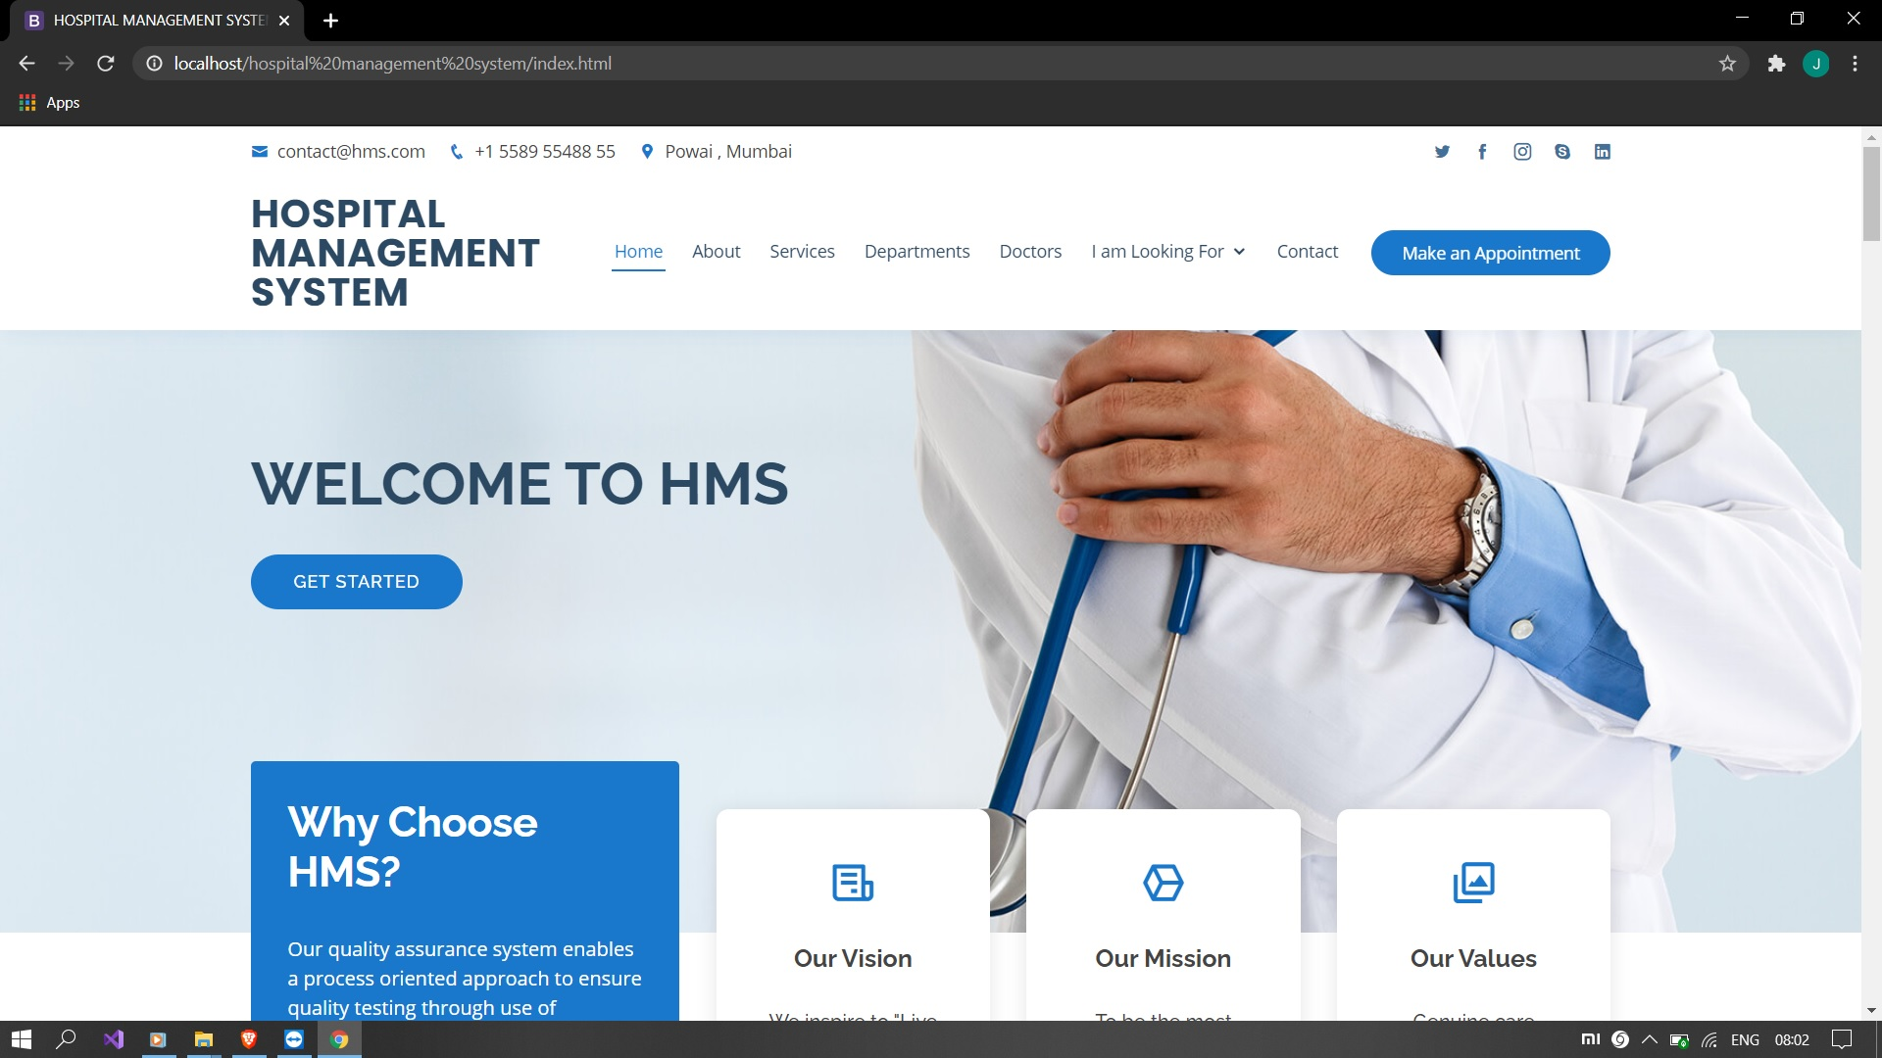

TEAM PAGE

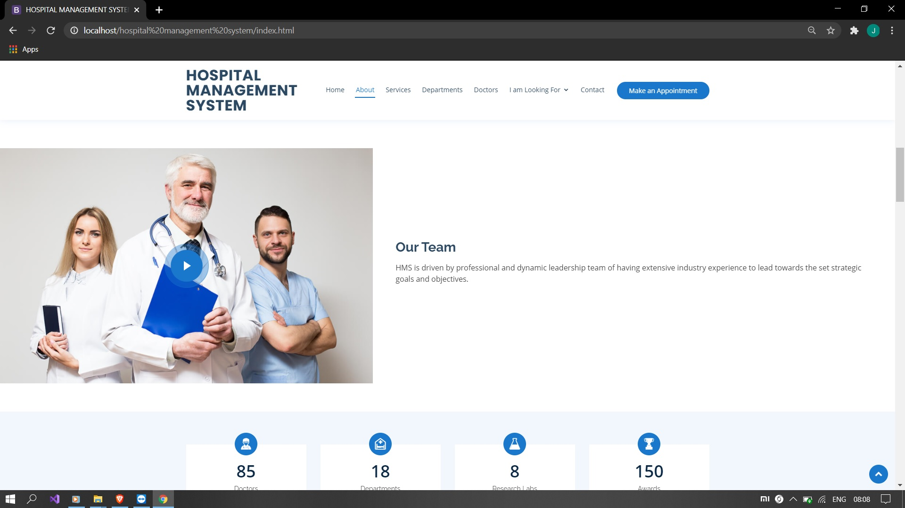

SERVICES

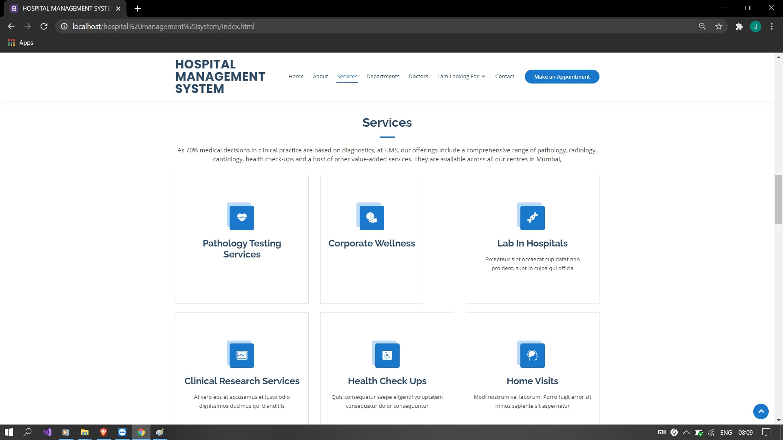

DEPARTMENTS

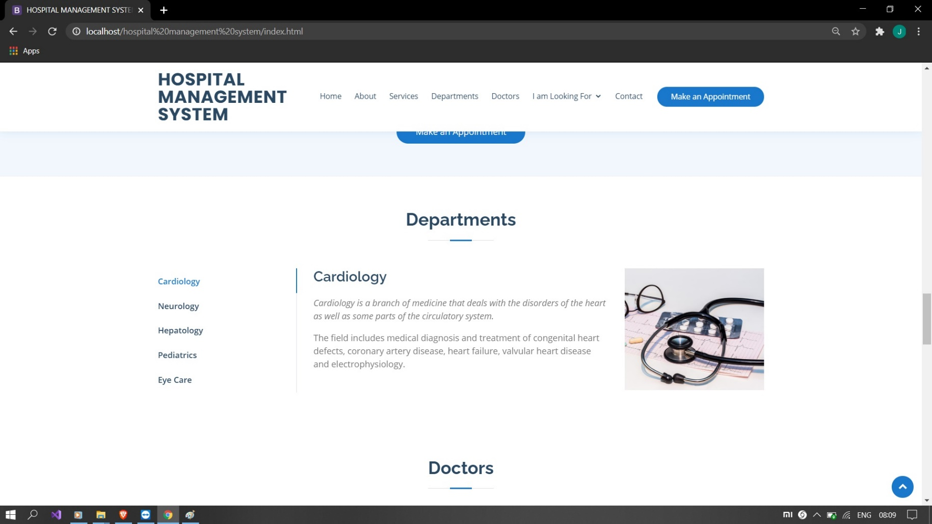

DOCTOR

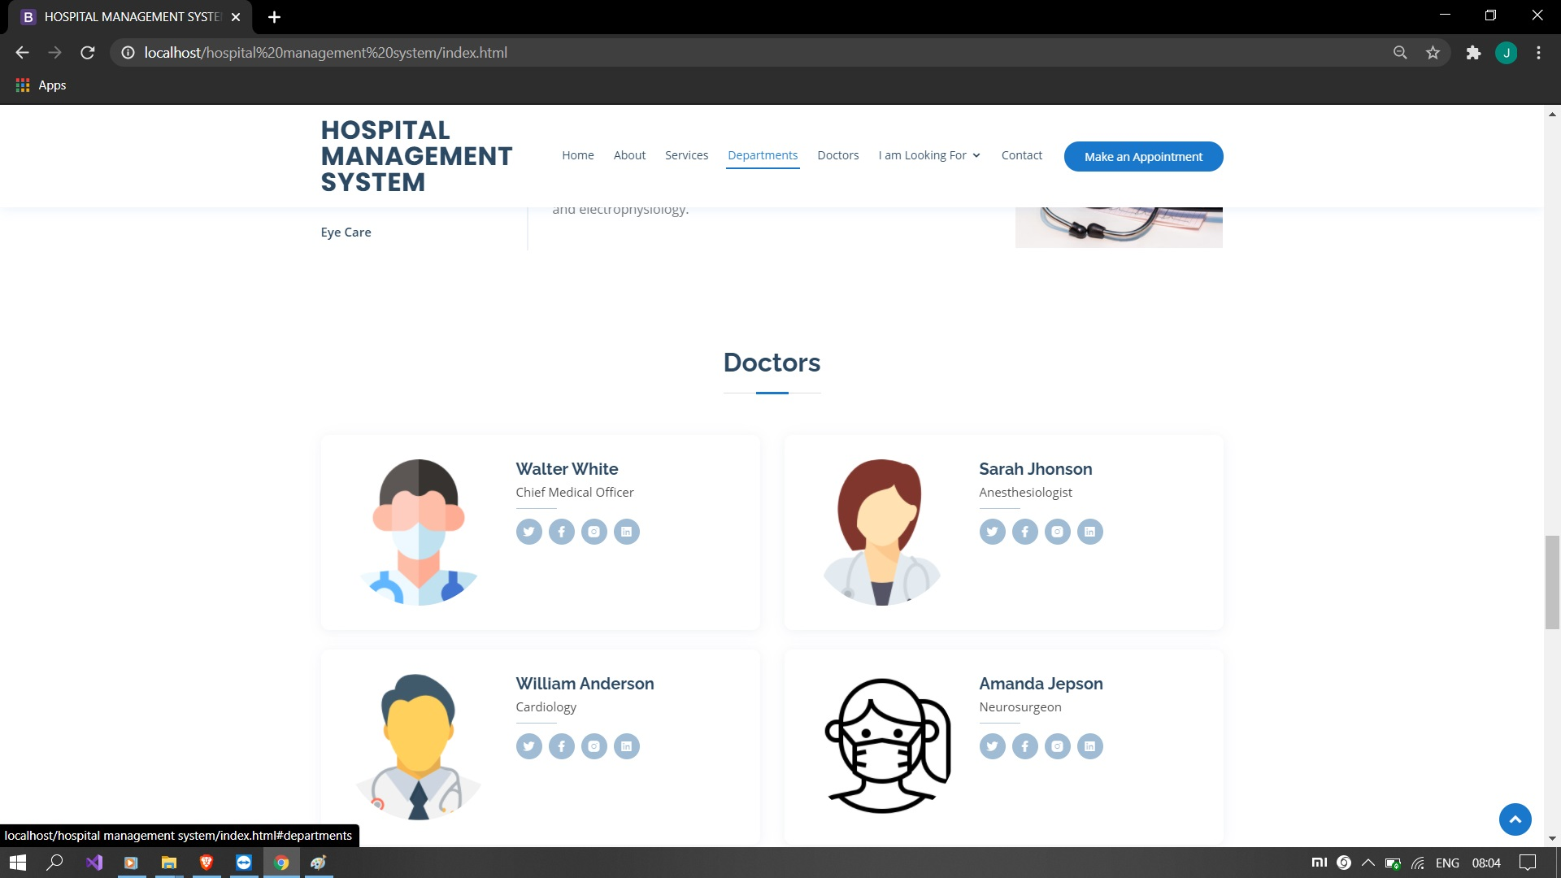

GALLERY

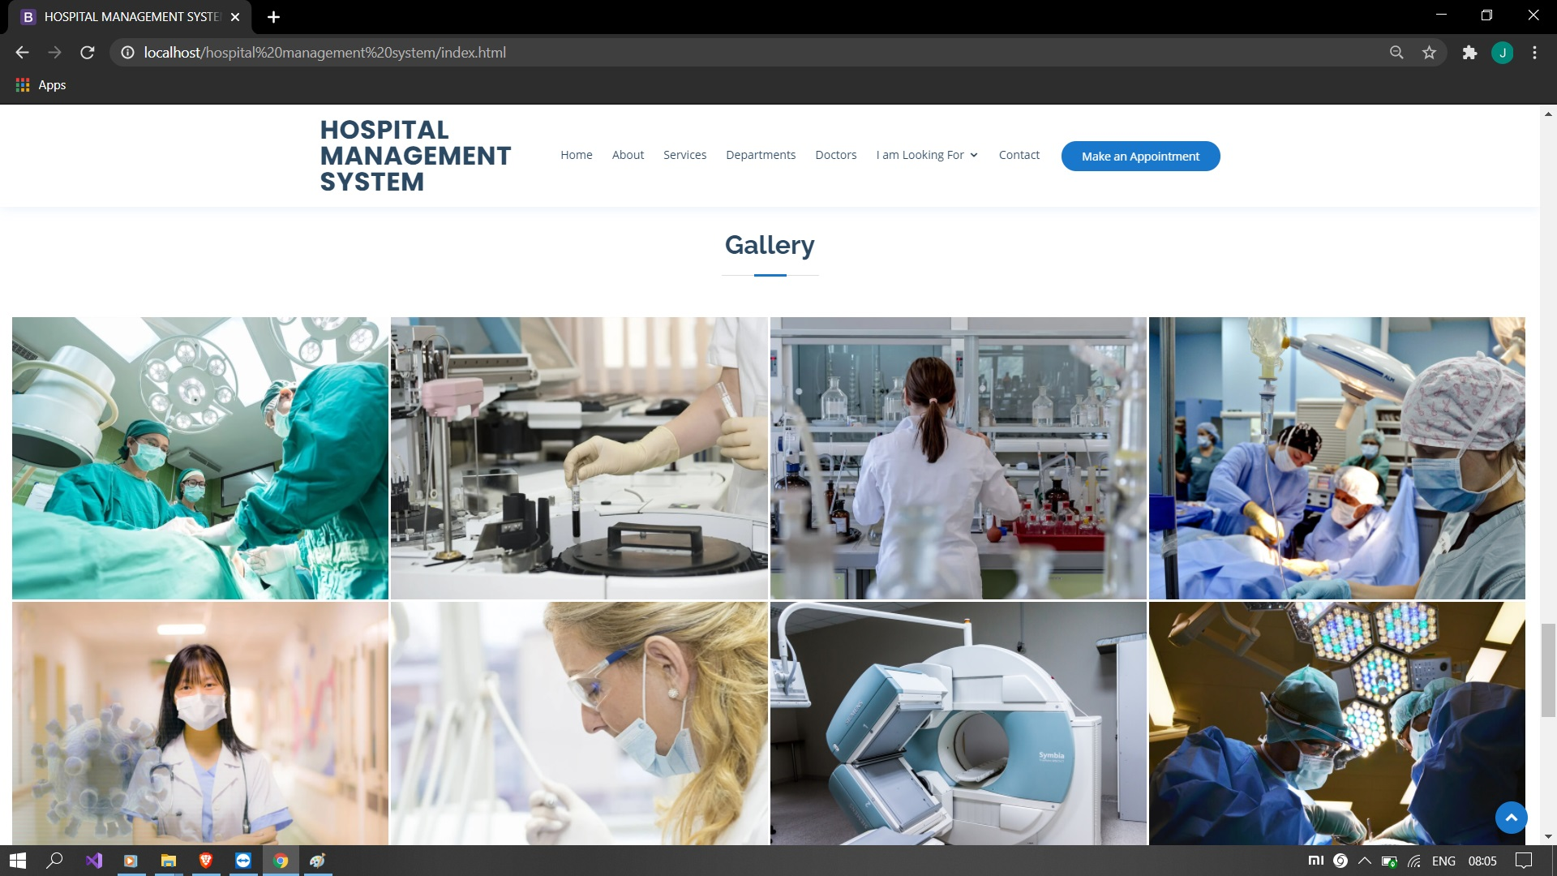

LOCATION

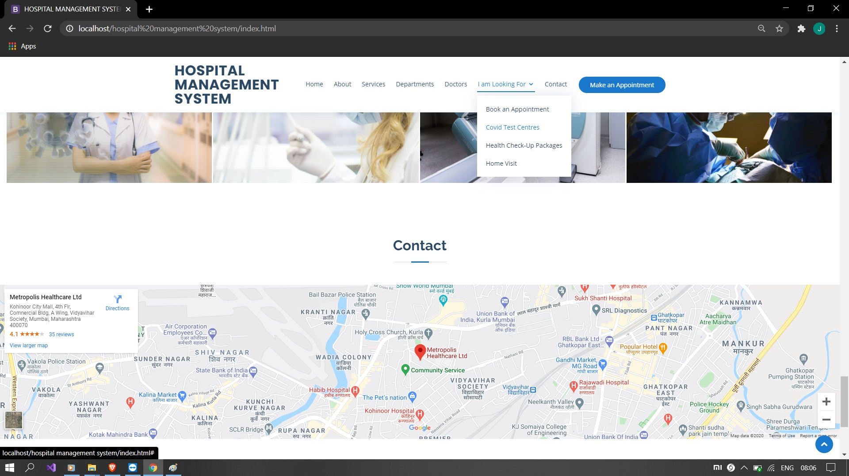

APPOINTMENT PAGE

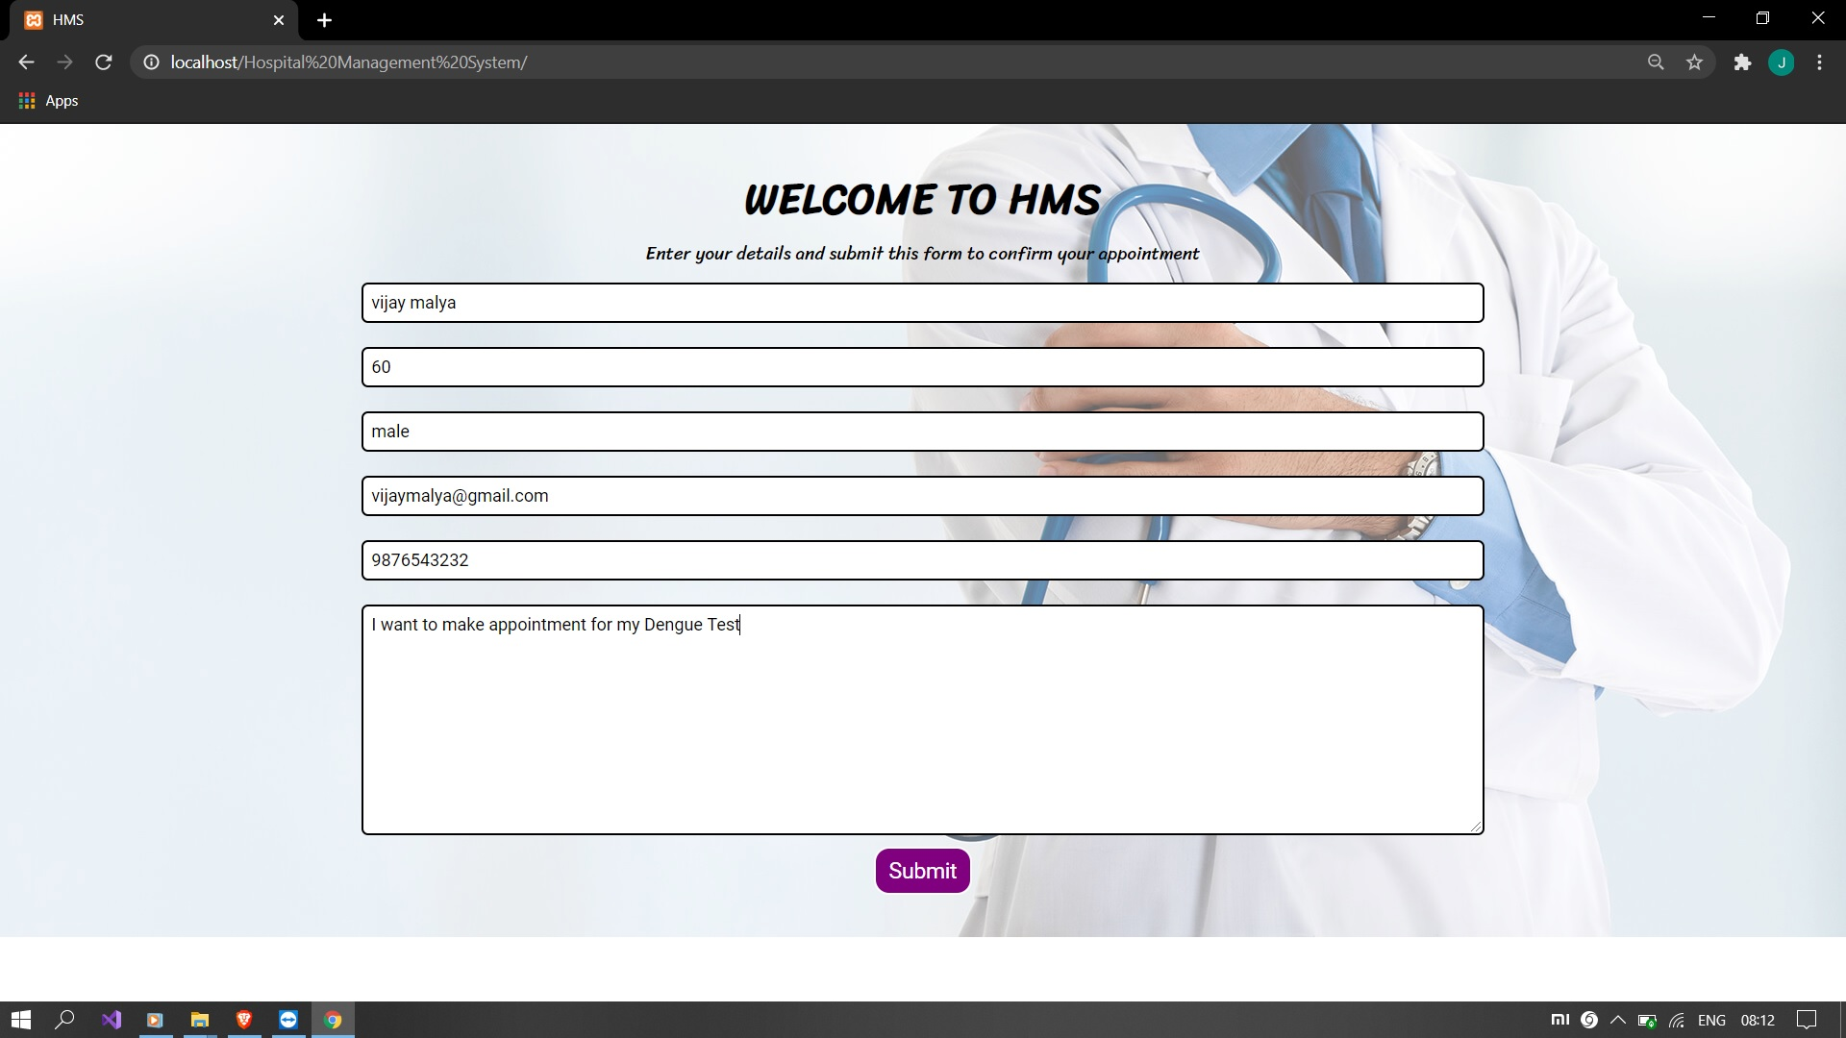

APPOINTMENT DATABASE

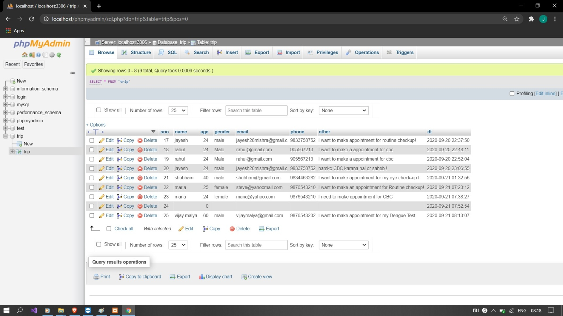

RETRIVE PAGE ON WEB

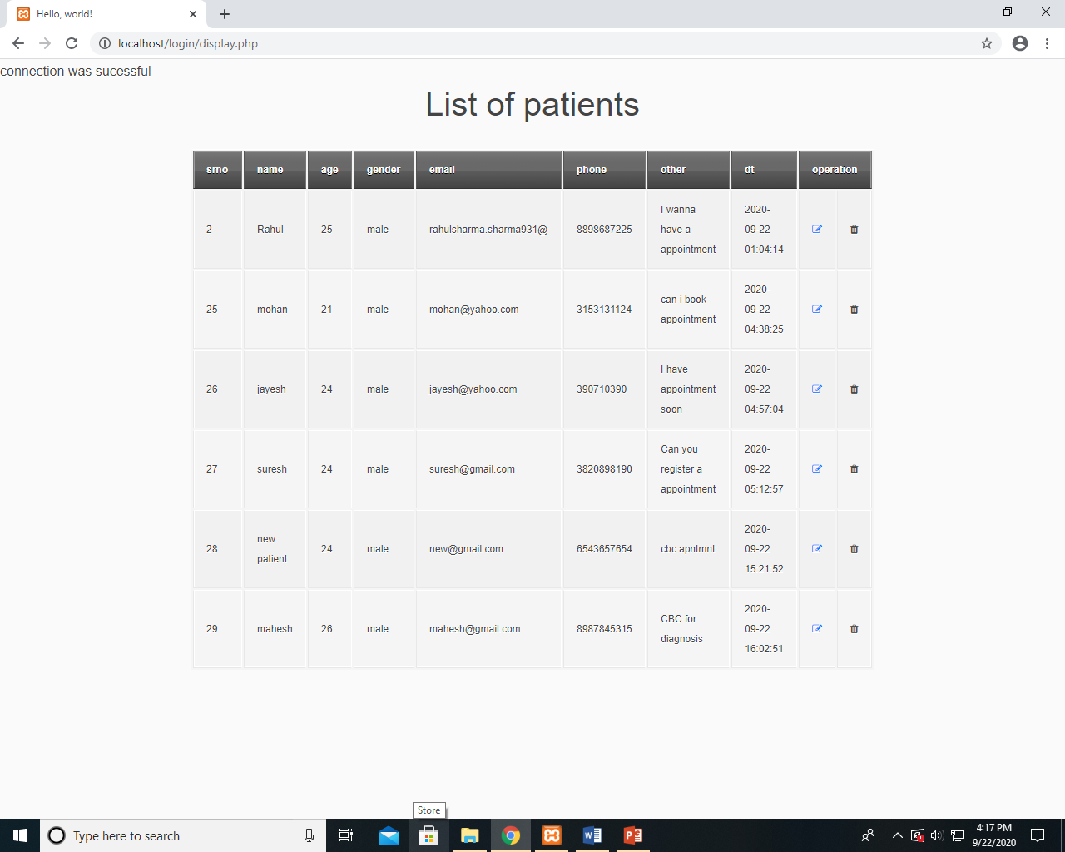

DATABASE

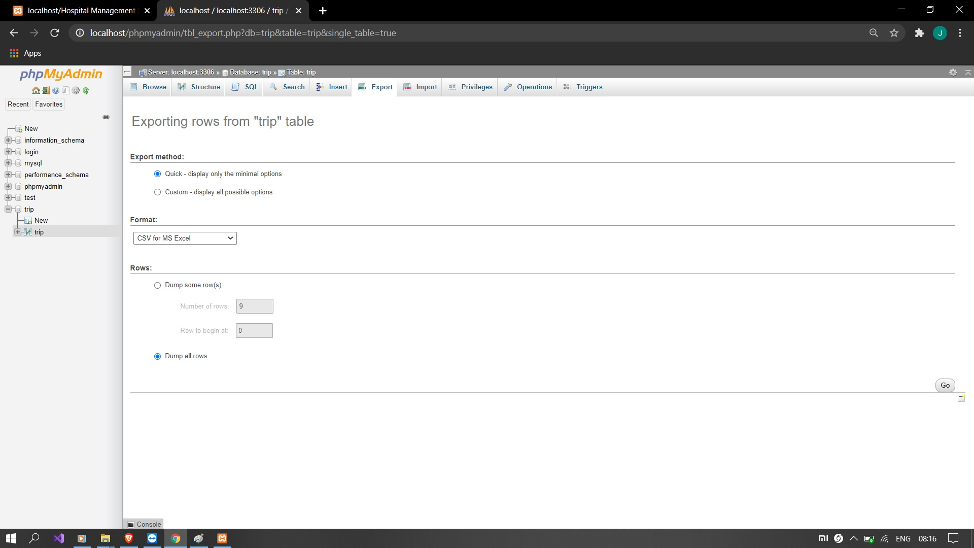

DATABASE IN DIFFERENT FORMAT

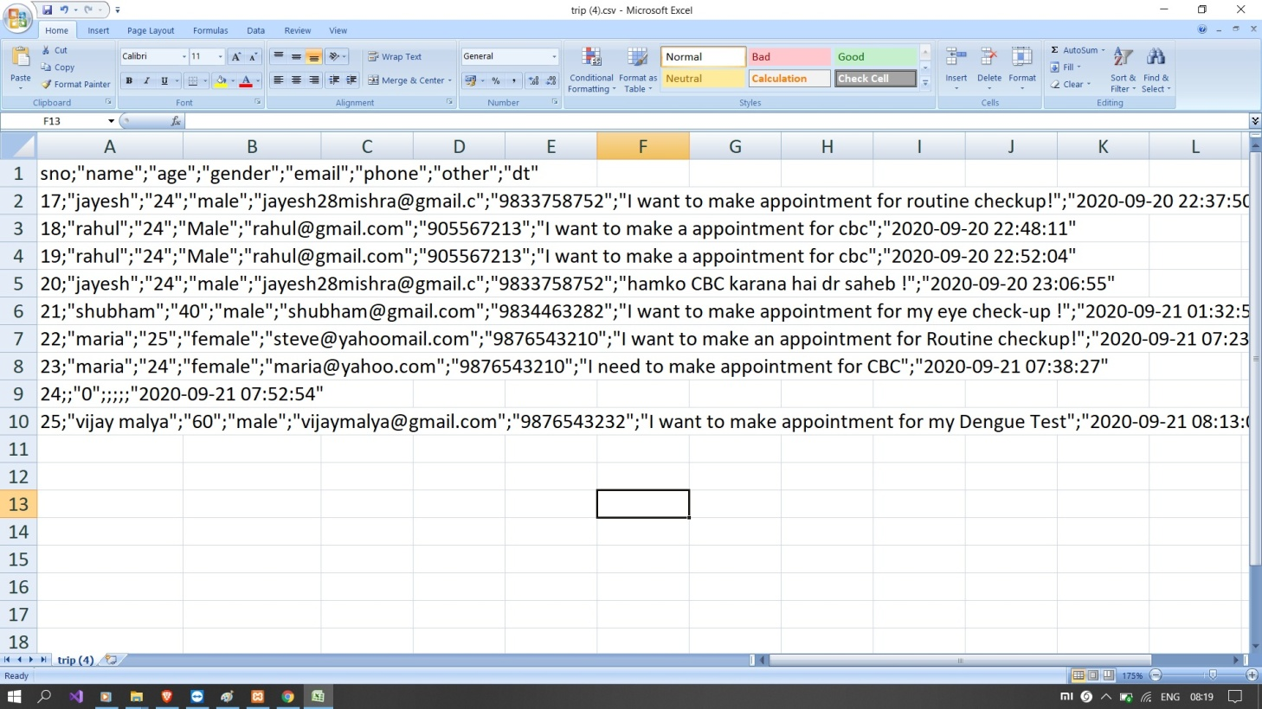

CONCLUSION

CONCLUSION:

The package was designed in such a way that future modifications can be done easily. The following conclusion can be deduced from the development of the project.

  - Automation of the entire system improves the efficiency
  - It provides a friendly graphical user interface which proves to be better when compared to the existing system.
  - It gives appropriate access to the authorized users depending on their permissions.
  - It effectively overcomes the delay in communications.
  - Updating of information becomes so easier.
  - System security, data security and reliability are the striking features.
  - The System has adequate scope for modification in future if it is necessary.

FUTURE ENHANCEMENTS

FUTURE ENHANCEMENTS:

This application avoids the manual work and the problems concern with it. It is an easy way to obtain the information regarding the various travel services that are present in our System.
Well I and my team member have worked hard in order to present an improved website better than the existing one’s regarding the information about the various activities. Still, we found out that the project can be done in a better way. Primarily, In this system patient login and then go to reception. By using this patient will send request for consulting the doctor. Reception will set the date for doctor appointments. After that doctor see his appointments and see the patients, surgeries also done.
The next enhancement is, we will develop online services. That mean, if patient have any problems he can send his problem to the doctor through internet from his home then doctor will send reply to him. In this patients have some login name and password.

BIBILOGRAPHY

BIBLIOGRAPHY

The following books were referred during the analysis and execution phase of the project

MICROSOFT Html WITH C#
Microsoft Html series

ASP Html 2.0 PROFESSIONAL
Wrox Publishers

ASP Html WITH C# 2005
Apress Publications

C# COOK BOOK
O reilly Publications

PROGRAMMING MICROSOFT ASP Html 2.0 APPLICATION
Wrox Professional Guide

BEGINNING ASP Html 2.0 E-COMMERCE IN C# 2005
Novice to Professional.

WEBSITES:
www.google.com
www.microsoft.com
www.collegedunia.com/courses/bachelor-of-hospital.com
www.www.shiksha.com/medicine-health-sciences.com
www.mocdoc.in/blog/a-detailed-view-of-hospital-management.com
www.doctors.practo.com/hospital-management-system.com
www.docengage.in/hospital-management-system.com
www.electronichealthreporter.com/importance-of-the-hospital.com

